Bridgepoint Parts Catalog

Section XXX: Engine Parts Page 1

PP42-902339

Air Filter – Kubota

Paper Filter – Cylinder
Prochem: Bruin II

PP42-902309

Oil Filter – Kubota Large
Prochem: Apex gas & diesel,
& Bruin II
Blueline: Bluewave gas & diesel
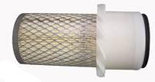


3.27” x 7.00”

PCU122-0469

Oil Filter – Onan Performer

24HP
Prochem: 150 (New Style) & Bruin
Bridgepoint: Lancer (Old Style)
Hydramaster: Crossfire 4.2 & Profire 4.7

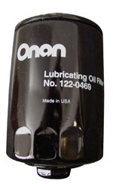

PBL36173

Oil Filter – Kubota Small
Prochem: Apex gas & Apex diesel
Sapphire: 570SS,
Bluewave gas & Bluewave diesel



PPR001

Oil Filter – Yanmar
Pramac: GSW50Y Generator

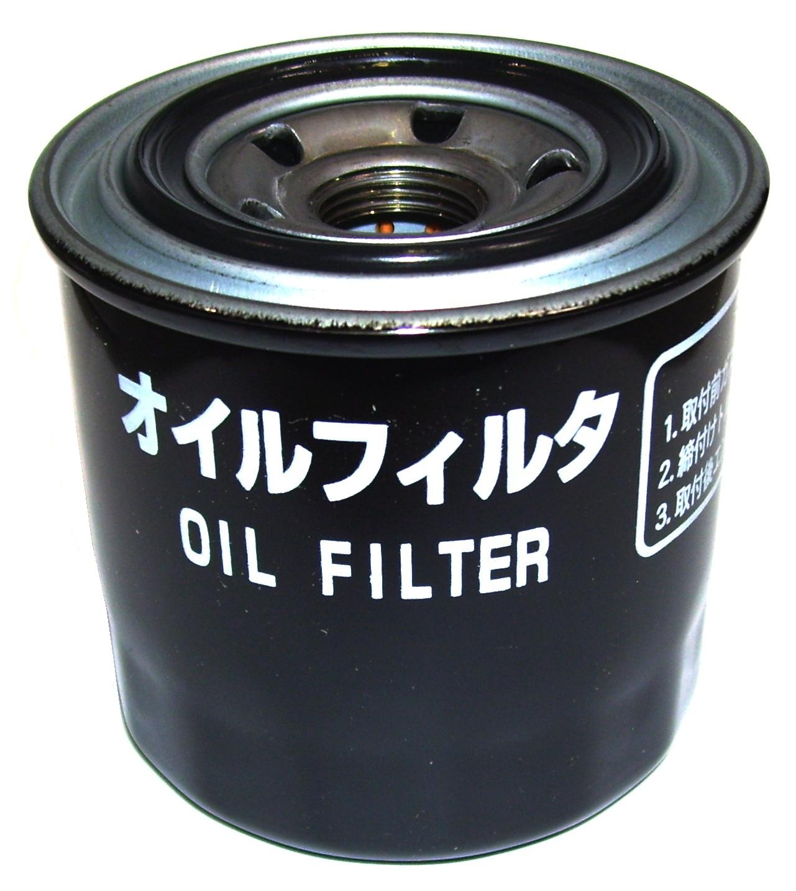

PGE149-2206

Fuel Filter - Onan
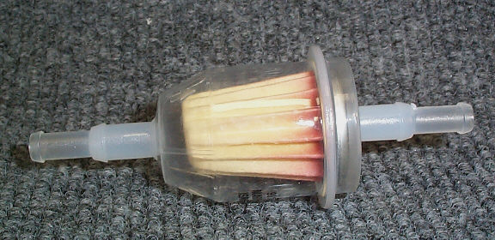

PPR002

Fuel Filter – Yanmar
Pramac: GSW50Y Generator

PHY049-046

Oil Filter - Honda
Hydramaster: Crossfire 4.2H & Crossfire 4.2XL

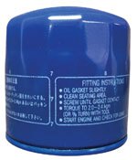
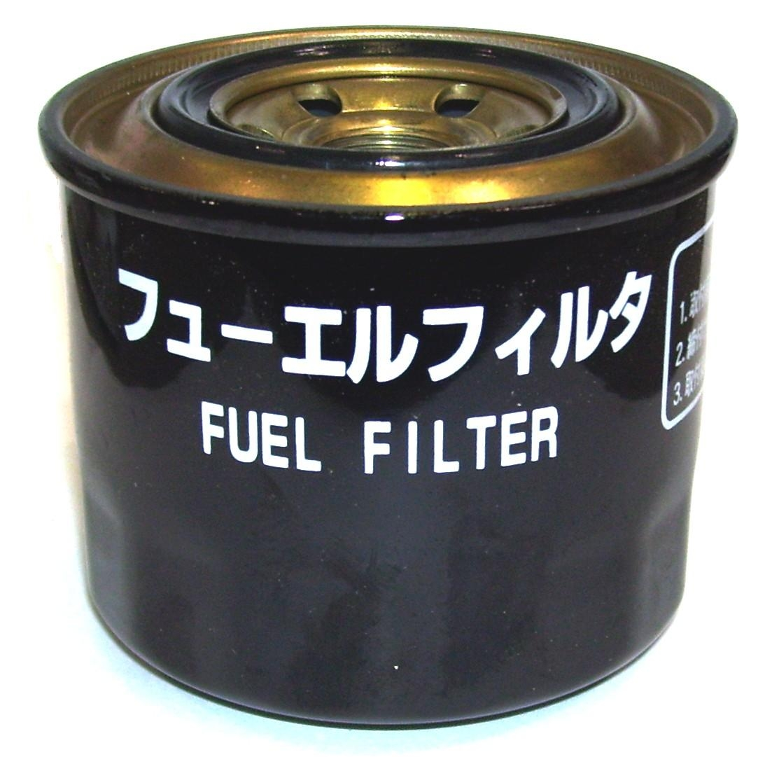

PHY049-045

Air Filter - Honda

Paper Filter – Flat
Hydramaster: Crossfire 4.2H & Crossfire 4.2XL

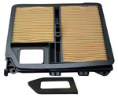

PHY049-048

Oil Filter – Kawasaki
Hydramaster: Crossfire 4.2K & Crossfire 4.4

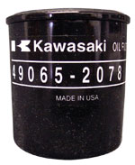

PWM-E4FZ6731AB

Oil Filter – Ford
White Magic: Pro 1900

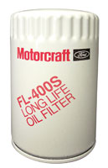

PHY049-047

Air Filter - Kawasaki

Paper Filter – Oval
Hydramaster: Crossfire 4.2K & Crossfire 4.4

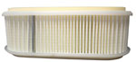

PBL36249

Fuel Filter – GMC Vortec EFI
Hydramaster: Titan 875
Blueline: Thermalwave II & IIHP

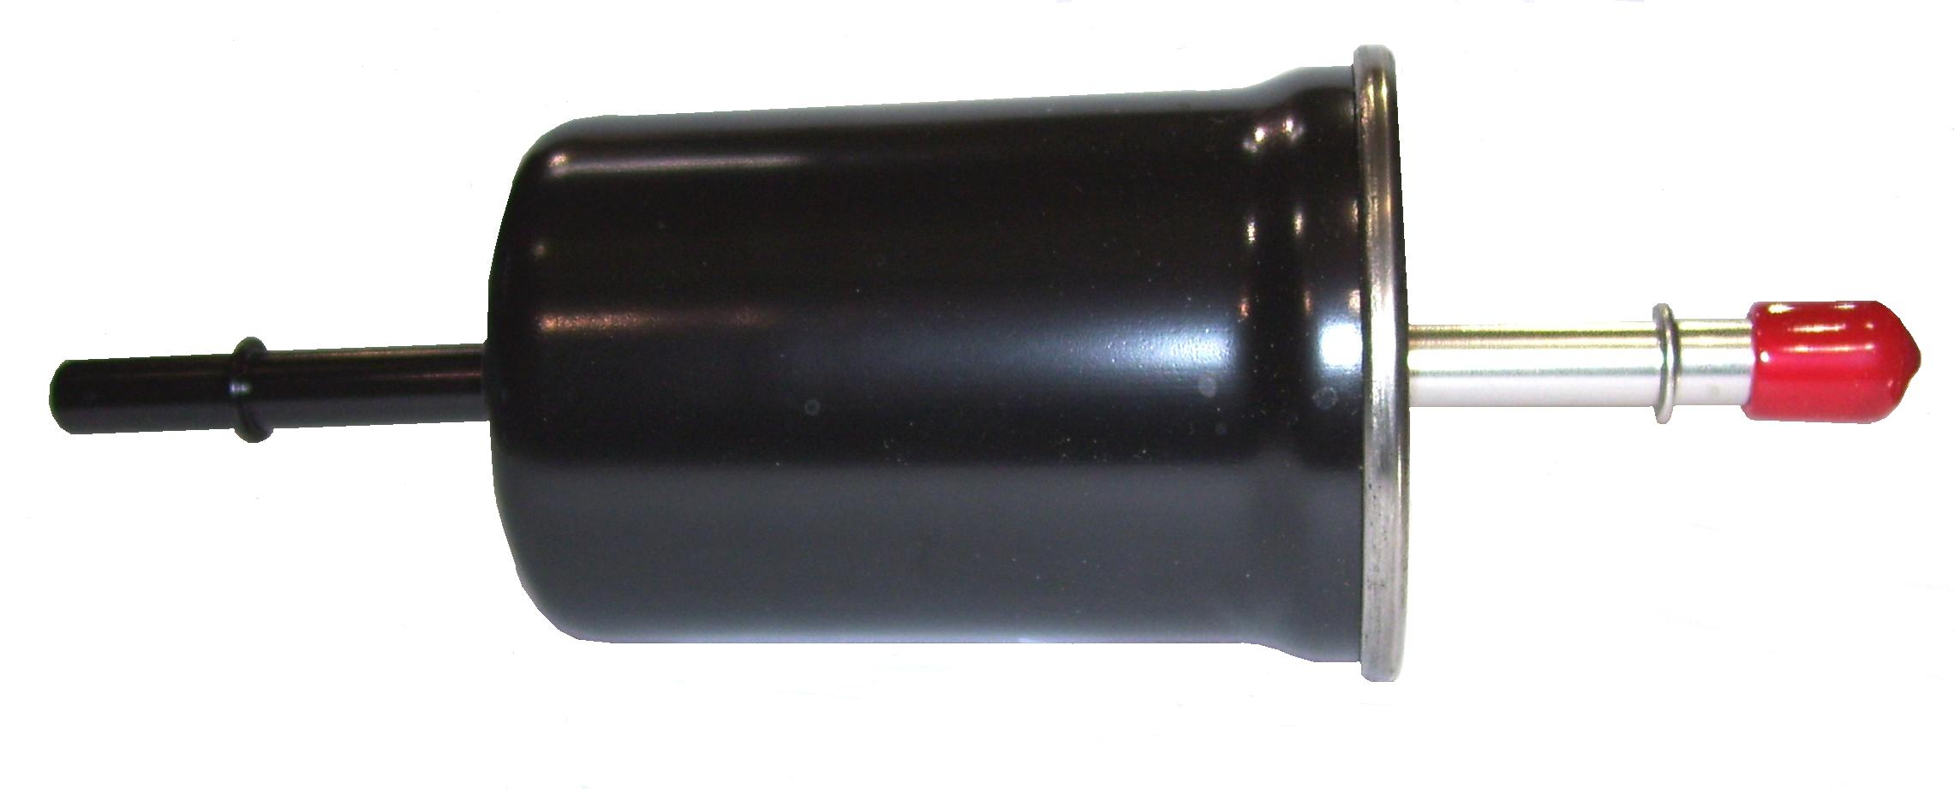

PWM-P827653

Air Filter – Ford

Paper Filter - Cylinder
White Magic: Pro 1900
Pramac: GSW50Y Generator

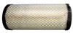

PBL36246

Oil Filter – GMC Vortec EFI
Blueline: Thermalwave II & IIHP
Hydramaster: Titan 875

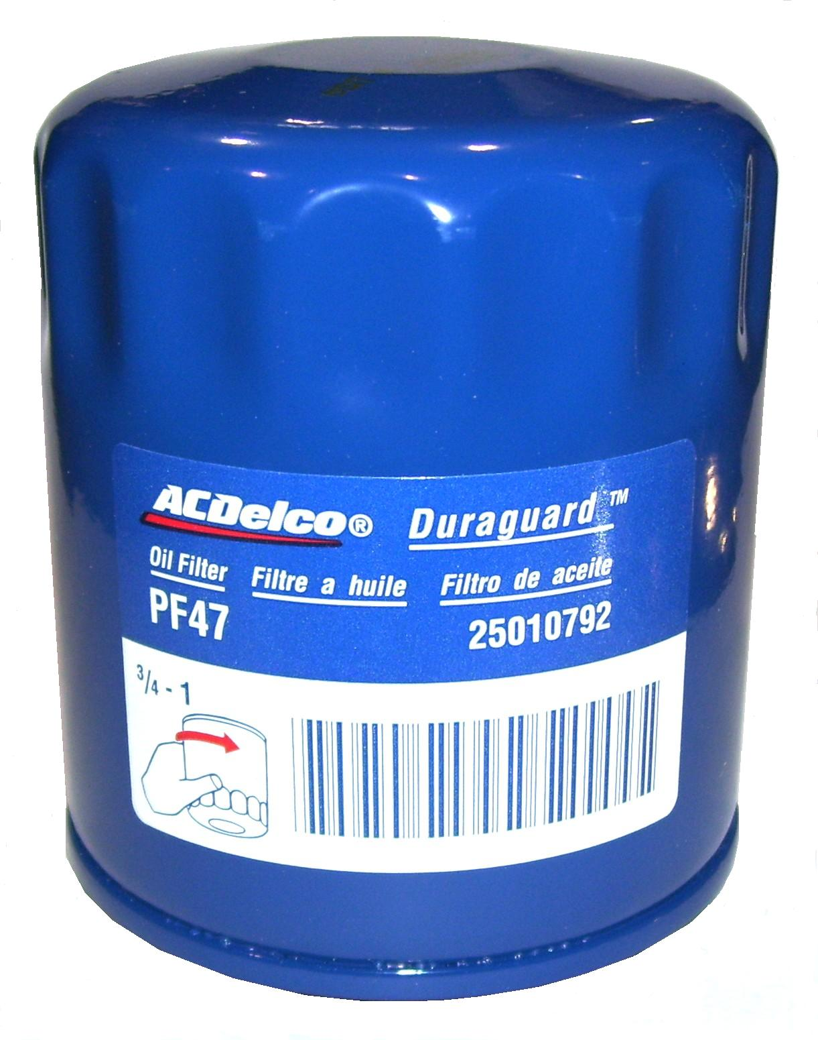

5.44” x 12.67”

PP790779

Air Filter

Paper Filter – Cylinder
Prochem: Everest EFI, Everest 408,
Everest 650, Apex Gas & Diesel
Blueline: Thermalwave 5M & 5M HP

PP0001

Oil Filter - Hyundai
Prochem: Everest 408 & 408 HP,
Everest 650 & 650 HP

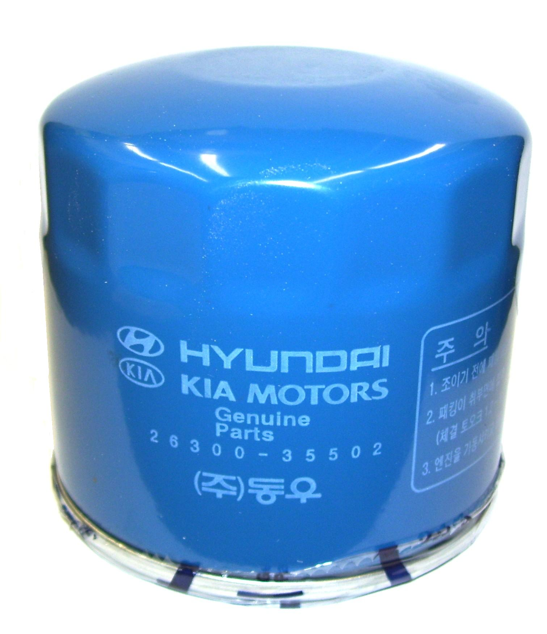

4.13” x 11.81”

PHY049-002

Fuel Filter – Metal

5/16” Barbs

PHY049-049

Fuel Filter – Metal

1/4” Barbs

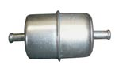

Bridgepoint Parts Catalog

Section XXX: Engine Parts Page 2

PGE149-1828

Fuel Pump – Onan Facet

(Round)

Prochem: 150 (New Style) & Bruin
Bridgepoint: Lancer (Old Style)
Hydramaster: Crossfire 4.2 & Profire 4.7

PCU167-0272

Spark Plug – RS17YX

Onan 24HP Performer
Prochem: 150 (New Style) & Bruin
Bridgepoint: Lancer (Old Style)
Hydramaster: Crossfire 4.2 & Profire 4.7

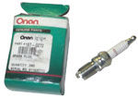
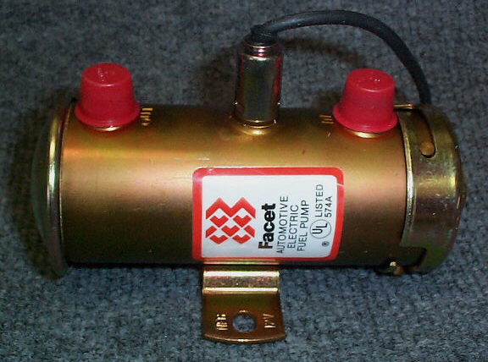

PHY106-017

Spark Plug

Honda 20HP Engine
Hydramaster: Crossfire 4.2H & Crossfire 4.2XL

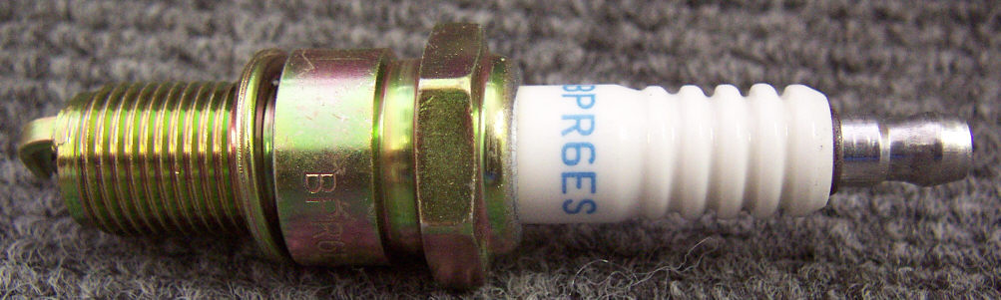

PGE191-1949

Starter – Onan 24HP Performer

Prochem: 150 (New Style) & Bruin
Bridgepoint: Lancer (Old Style)
Hydramaster: Crossfire 4.2 & Profire 4.7

PHY106-032

Spark Plug

Kawasaki 20HP Engine
Hydramaster: Crossfire 4.2K & Crossfire 4.4

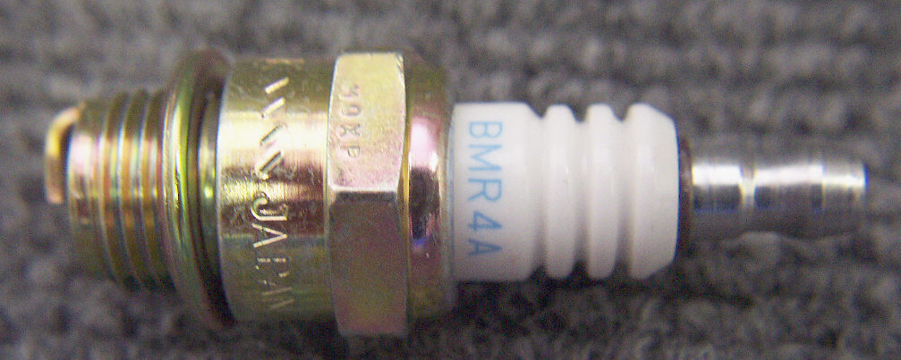

PCU191-2227

Voltage Regulator – Onan 24HP Performer

Prochem: 150 (New Style) & Bruin
Bridgepoint: Lancer (Old Style)
Hydramaster: Crossfire 4.2 & Profire 4.7

PP42-902312

Spark Plug (Use PFR-RC-12YC)

Kubota 23HP Engine
Prochem: Bruin II
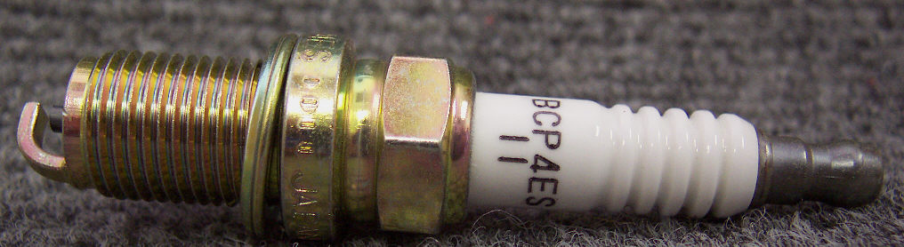

PHY135-035

Voltage Regulator – Honda

20HP Engine

Hydramaster: Crossfire 4.2H & Crossfire 4.2XL

PHY152-008

Coupling #6 Rubber Sleeve
Hydramaster: Bobcat, Aquacat, Hydracat 3.5, Spitfire 3.2 &
Spitfire 4.0 (older style). Bridgepoint: Dagger

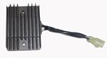
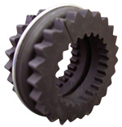

PHY135-019

Voltage Regulator – Kawasaki

20HP Engine
Hydramaster: Crossfire 4.2K & Crossfire 4.4

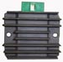

PHY152-001

Coupling #8 Rubber Sleeve
Hydramaster: Hydracat 4.0 & Hydracat 4.5

PHY039-004

Coupling Boot PX70
Hydramaster: Hydracat S

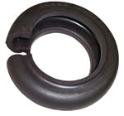

PFR-RC12YC

Spark Plug RC12YC

Kohler Engines
Sapphire: Bluewave Gas & 570SS
Prochem: Apex Gas

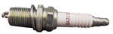

PHY106-045

Plug Rubber Coupling

Spitfire 4.0 & Boxxer 421
(Requires 8 plugs per coupler)

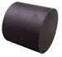

PHY152-010

Sleeve Rubber Coupler

Boxxer 427

PHY139-022

Ring 5” Coupler Retainer

Spitfire 4.0 & Boxxer 421

PHY174-080

Washer 5” Coupler Retainer

Spitfire 4.0 & Boxxer 421

Bridgepoint Parts Catalog

Section XXX: Engine Parts Page 3

PCU140-1216

Air Filter – Onan B43M
Prochem: 150 (Old Style)

PGE140-1907

Air Filter – Onan
Hydramaster: Hydra Cat S &
Hydra Cat L

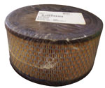

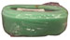

PCU140-2522

Air Filter – Onan B46G
Prochem: 150 (Old Style)

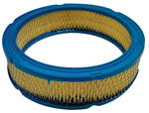

PDE-FD103

Spark Plug – Ford VSG-411/413
White Magic: Pro 1900
Hydramaster: Maxx 550

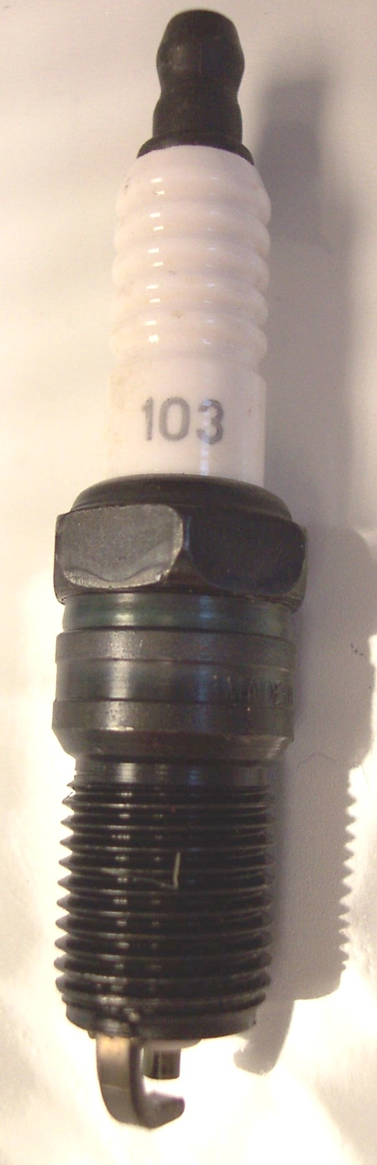

PP49-802505

Throttle Cable Assembly
Fits Most Machines
Cut to length

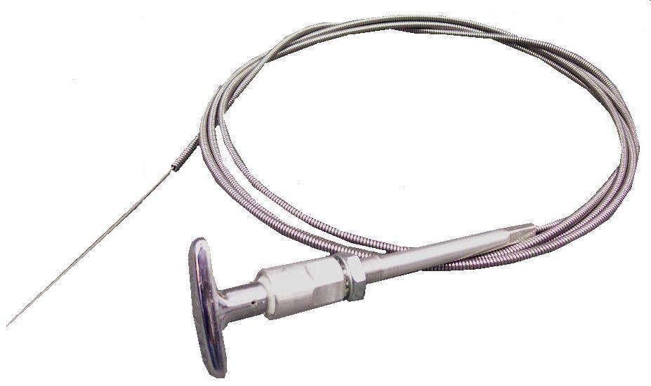

PP0002

Spark Plug – Hyundai
Prochem: Everest 408 & 408 HP,
Everest 650 & 650 HP

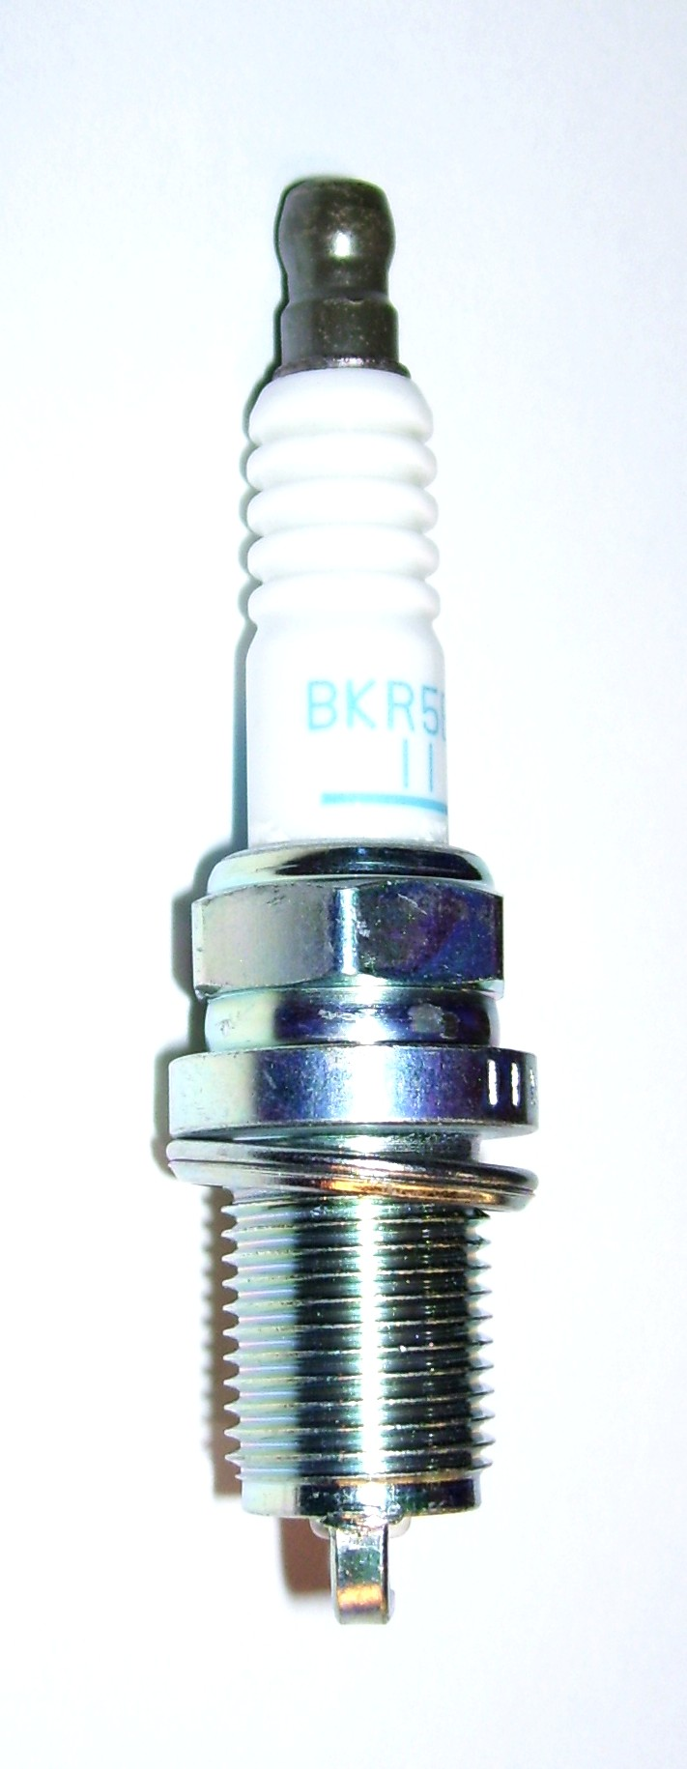

PP49-802518

Choke Cable Assembly
Fits Most Machines
Cut to length

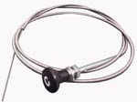

PBL0001

Spark Plug – GMC Vortec EFI
Blueline: Thermalwave II
& Thermalwave II HP
Hydramaster: Titan 875

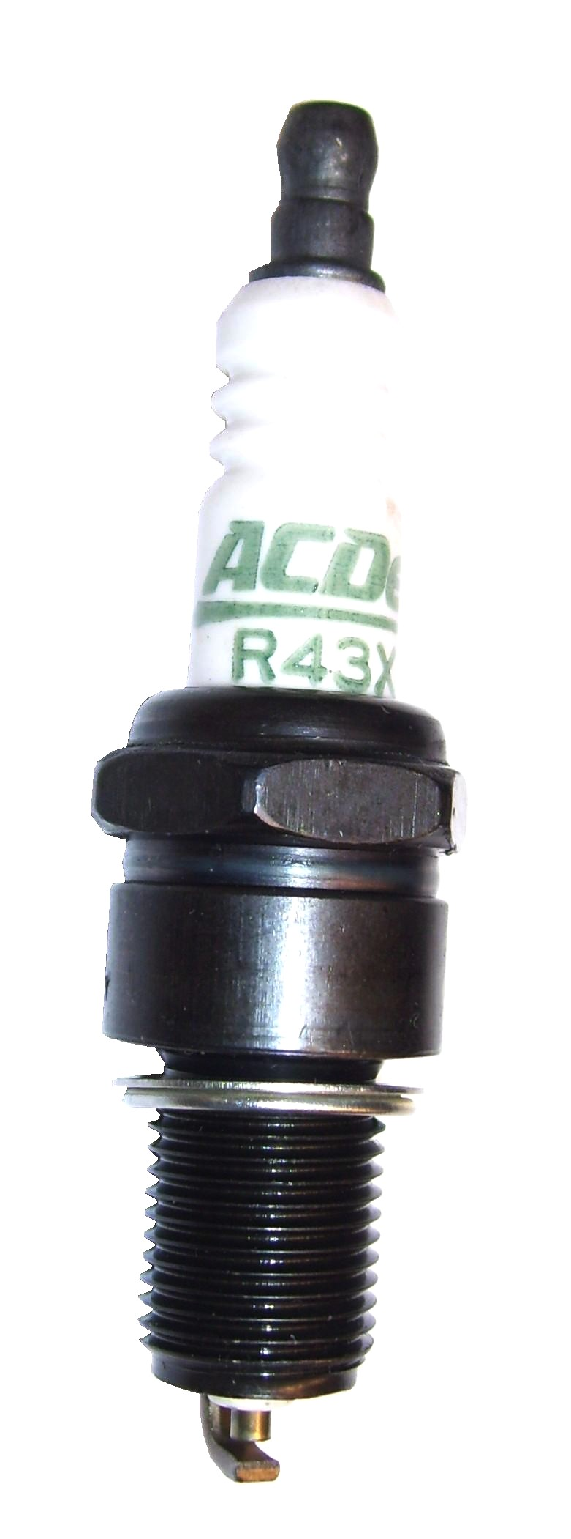

PHY025-002

Choke Cable Assembly
Fits Most Machines - Cut to length
(Shorter than PP49-802518)

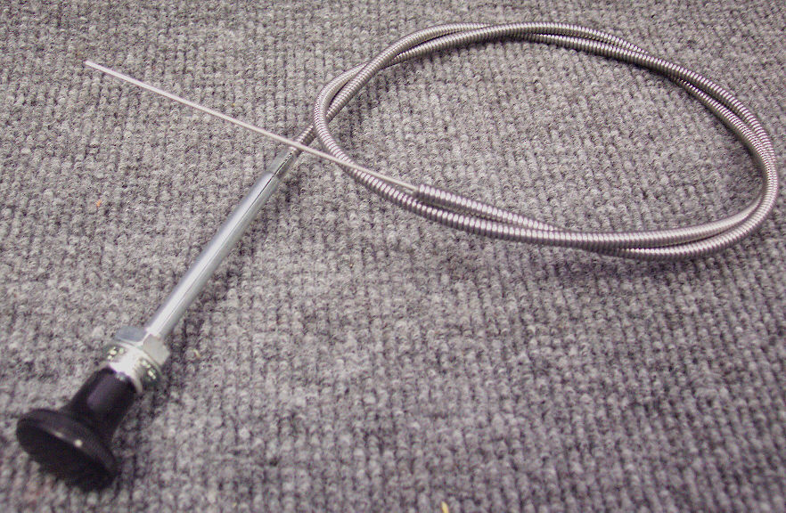

PBL36209

Air Filter Secondary Blueline
Sapphire: Bluewave, 570SS,
Thermalwave II
& Thermalwave II HP
Hydramaster: Titan 875
2-1/2” diameter x 10-1/4” long

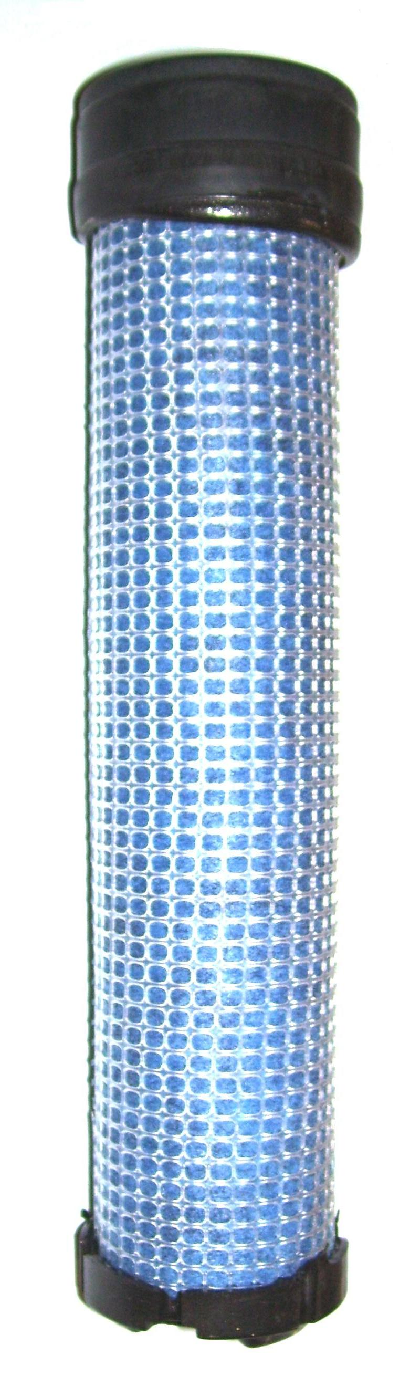

PHY025-020

Throttle Cable Assembly
Hydramaster: Boxxer 318, Boxxer421, Boxxer 427
& Boxxer H2O

Cut to Length

PP791096

Throttle Cable - Peak

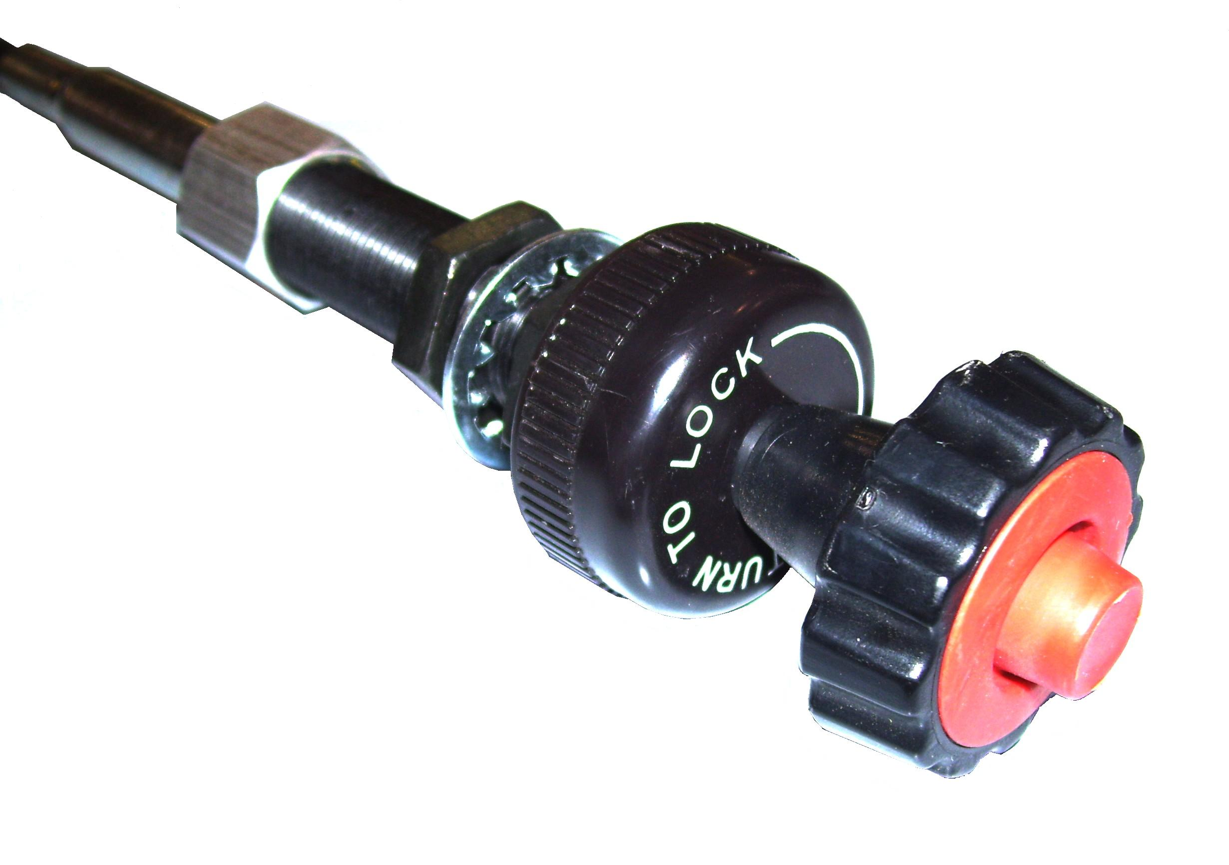

PD25-08301S

Air Filter - Kohler

Filter Cartridge – Primary
Hydramaster: Titan 875
Prochem: Peak
Blueline: Bluewave, 570SS, Thermalwave II
Thermalwave II HP.
4” diameter x 10-3/4”high

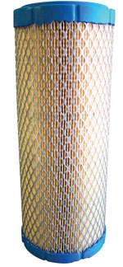

PCU140-2628-1

Air Filter – Onan Performer 24HP
Prochem: 150 (New Style) & Bruin
Bridgepoint: Lancer (Old Style)
Hydramaster: Crossfire 4.2 & Profire 4.7

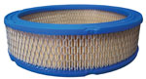

PBL36174

Zeems Controller – Nissan EFI
Prochem: Everest EFI &
Everest HP EFI
Blueline: Thermalwave II Nissan &
Thermalwave II HP Nissan.

PCU140-1496-01

Air Filter – Pre-cleaner

Onan Performer 24HP
Prochem: 150 (New Style) & Bruin
Bridgepoint: Lancer (Old Style)
Hydramaster: Crossfire 4.2 & Profire 4.7

